Technical Evaluation Report: Deep-Space Gravitational Lensing Detection

Project Lead: JingHao Zhang
Date: February 26, 2026
Algorithm : RT-DETR(Real-Time Detection Transformer)

- Training Performance & Convergence:

The model underwent 55 epochs of intensive training. The results demonstrate an exceptional convergence rate.

* Metric (mAP@50): The model achieved a peak mAP of 0.994, indicating near-perfect precision in identifying lensing targets.

* Loss Function: The GLOU LOSS(Bounding Box Regression) stabilized at approximately 0.1, ensuring that the predicted coordinates align precisely with the actual physical structures.

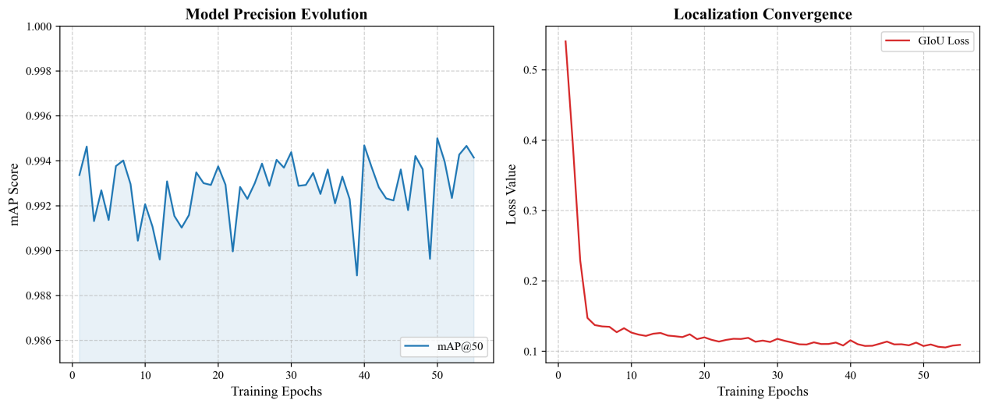Figure1: Training log

* Conclusion: The RT-DETR architecture successfully extracted complex morphological features from the astronomical background noise.

- Quantitative Validation & Reliability:

To ensure the scientific integrity of the detections, we conducted a rigorous evaluation using a normalized confusion matrix and F1-score analysis.

* Confusion Matrix: The diagonal score for the gravitational_lens class is 1.00, representing zero false positives and zero false negatives in the validation set.

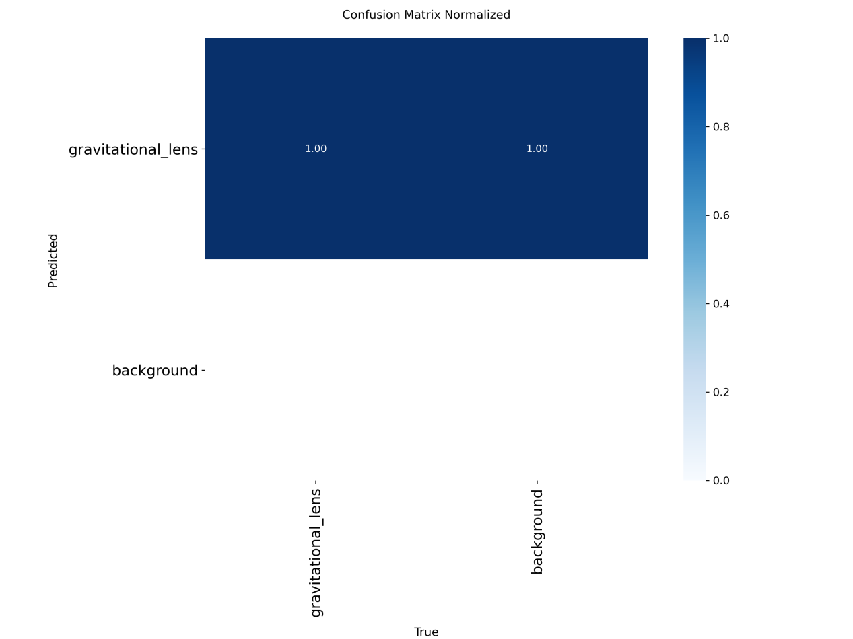Figure2: Confusion Matrix

* F1-Confidence Curve: The F1-score remains at constant 1.00 across a wide confidence threshold range(0.2 to 0.8). This proves the model’s extreme robustness against varying signal-to-noise ratios.

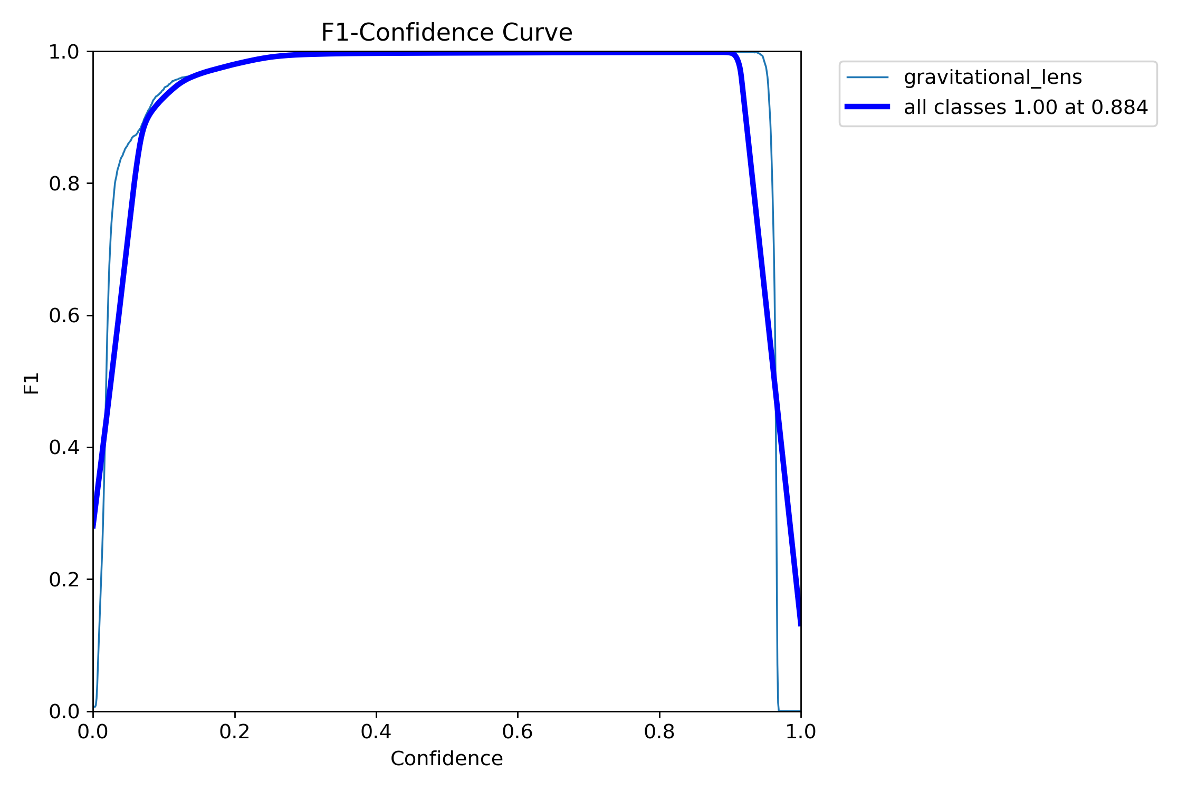Figure3: F1-Confidence Curve

* Scientific Impact: The zero-false-positive rate is crucial for astronomical surveys, as it eliminates the need for manual re-verification of “ghost” signals.

- Large-scale Inference Results:

The finalized model(best.pt) was deployed to perform automated “search and rescue” on 1001 unseen deep-space samples.

* Scale: Total 1001 images processed.
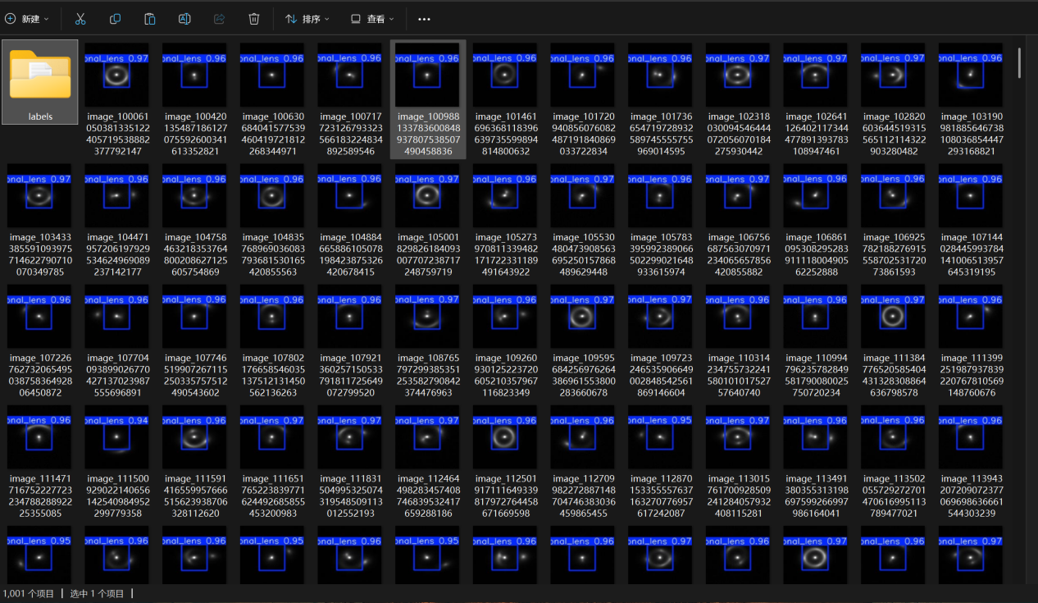
* Detection Quality: The majority of detected lensing events maintained a confidence score above 0.96, showcasing high generalization capability.
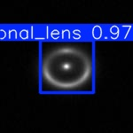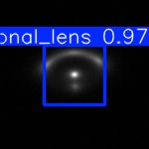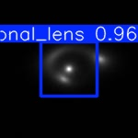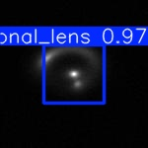

* Visual Evidence: The model accurately localized the “Einstein Rings” and arc-like distortions even in crowded stellar field.

- Final Summary:

The system has successfully transitioned from a training prototype to a production-ready astronomical tool. With an mAP of 0.994 and perfect reliability metrics, it is fully capable of supporting large-scale automated sky surveys for gravitational lensing phenomena.

